Amal Group
163 SOUTH CIRCULAR ROAD, DUBLIN 8, IRELAND
TEL: (+353) 0876612020 / (+353) 0872976050: amal.hope@outlook.ie

Nomination Form for “The Best Girl” for International Girl Day 18th October 2015
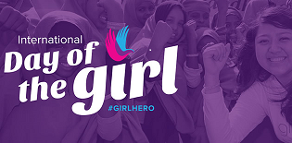

I, ______________________ (youth) would like to nominate __________________ (youth) to be “the best girl” of the year at the International Girl Day

Details of the person you nominated below

Name of Youth: __________________________________________

Mobile: __________________________________________

Why do you nominate her as the best girl of the year?

Please give details
________________________________________________________________

________________________________________________________________

I, _______________ (youth) understand, I have to pay €2 registration fee for the International Girl Day celebration for

I, _______________________ (parent name) also give full permission in the case of emergency for emergency treatment to be given.

Yes No

IFI is not responsible for my child after the event finished to arrange pick up or supervision.

Name in Block capitals (Youth): __________________________________________

Address: __________________________________________

Date of Birth (Youth): __________________________________________
Mobile (Parent/ Youth): __________________________________________

Signature (Parent): __________________________________________

Date: __________________________________________

